**EDUCATING LEADERS 2025 DIGITAL TOOLKIT**

The American Association of Colleges of Osteopathic Medicine (AACOM) is excited to welcome you to Educating Leaders 2025 (EL25), the AACOM Annual Conference, April 9-11. This year’s conference will be an in-person held in Arlington, Texas. Forge connections, ignite inspiration and catalyze change during this can’t miss event!

This digital toolkit provides a wide range of downloads and communications materials for AACOM’s [**EDUCATING LEADERS 2025**](https://www.aacom.org/programs-events/educating-leaders-2025) conference.

If you have any questions about the toolkit, please contact Inma Galvez-Shorts, Manager of Social Media and Analytics, at [igalvez-shorts@aacom.org](mailto:igalvez-shorts@aacom.org).

**FOLLOW AACOM ON SOCIAL MEDIA**

[Facebook](http://www.facebook.com/AmericanAssociationCollegesOsteopathicMedicine) | [X](https://twitter.com/AACOMmunities) | [Instagram](http://www.instagram.com/aacom_do) | [LinkedIn](https://www.linkedin.com/company/aacom_2)

**USE THE #HASHTAGS**

#EducatingLeaders25 | #EducateLeaders | #DOleaders

**DOWNLOADS AND SHAREABLES**

**ATTENDEE TOOLKIT**

Facebook/LinkedIn

* Excited to reconnect with my colleagues at AACOM’s #EducatingLeaders25! This April 9-11, join us in Arlington, TX for the nation’s premier osteopathic medical education event. It’s your chance to network, learn from thought leaders and be part of the innovation shaping the future of healthcare. Don’t miss it—register today: aacom.org/educatingleaders
* The future of medicine starts here! 🌟 Join me at #EducatingLeaders25, the leading event for osteopathic medical education, on April 9-11 in Arlington, TX. Get ready for dynamic keynotes, hands-on sessions and collaborative programming on the biggest challenges and opportunities in healthcare today. Be part of something bigger—register now: aacom.org/educatingleaders

Twitter/X

* Join me at @AACOMmunities’ #EducatingLeaders25 for 3 days of inspiration and collaboration on the future of osteopathic medical education! Let’s dive into the key issues and opportunities shaping healthcare today. Register now: aacom.org/educatingleaders
* Excited to hear from @SPEAKER, @SPEAKER and @SPEAKER at @AACOMmunities’ #EducatingLeaders25! Who else is joining me? aacom.org/ educatingleaders
* Proud to be part of #EducatingLeaders25, where the future of healthcare starts with innovative osteopathic medical education. Join us April 9-11 and help shape tomorrow’s healthcare leaders! Register here: aacom.org/educatingleaders

[**Social media attendee graphics**](https://drive.google.com/drive/folders/1w-hEM3c7ZHvNoKzT4he5xeGHsQ4QVEef?usp=drive_link)

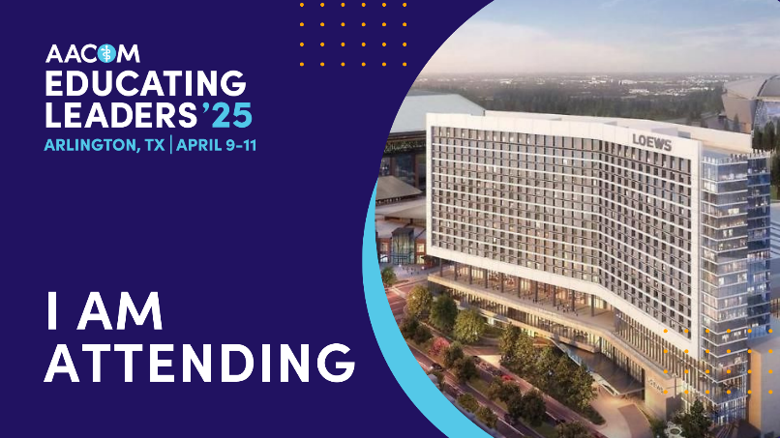 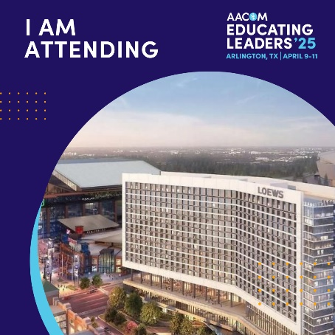

**PRESENTER TOOLKIT**

Facebook/LinkedIn

* Thrilled to announce that I’ll be presenting at #EducatingLeaders25! 🎉 Don’t miss out on the opportunity to explore critical topics in osteopathic medical education like workforce diversity, clinical training and boosting osteopathic representation. Let’s shape the future together—register now: aacom.org/educatingleaders
* Can’t wait to be part of AACOM’s #EducatingLeaders25! This April 9-11, join me in Arlington, TX for the largest gathering of leaders and innovators in osteopathic medical education. Let’s connect, learn and make an impact! Secure your spot today: aacom.org/educatingleaders

Twitter

* Excited to share that I’m presenting at @AACOMmunities’ #EducatingLeaders25! Join me and fellow #DOleaders April 9-11 to celebrate and advance osteopathic medical education. Don’t miss it—register here: aacom.org/educatingleaders
* I am honored to present my work at #EducatingLeaders25. Register and join me in Arlington, TX at @AACOMmunities’ annual conference on April 9-11! aacom.org/educatingleaders
* I'm presenting at #EducatingLeaders25! The path to better healthcare starts with better osteopathic medical education. Hope to see you there! @AACOMmunities aacom.org/educatingleaders

[**Social media presenter graphics**](https://drive.google.com/drive/folders/1E-GkC6YwNPGmJcTYRlk2-TrhEPrK70wJ?usp=drive_link)

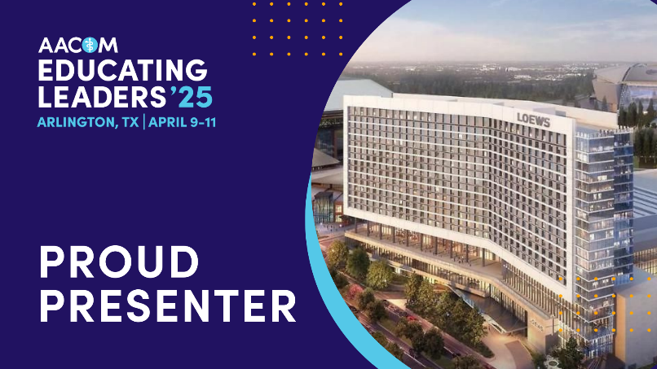 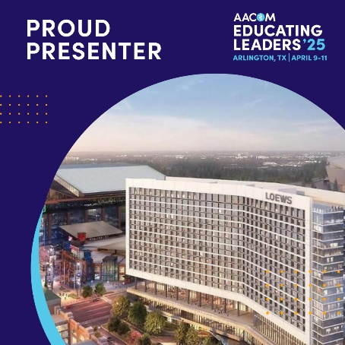

**SPONSOR/EXHIBITOR TOOLKIT**

Facebook/LinkedIn

* We're thrilled to be part of #EducatingLeaders25, where you can delve into three days of thought-provoking plenary presentations, interactive sessions, special events and collaborative programming focused on critical issues in healthcare and medical education. Join us from April 9-11 in Arlington, TX. Register and learn more at aacom.org/educatingleaders
* We take pride in being an exhibitor at #EducatingLeaders25! Register now and connect with leaders in osteopathic medical education, including students, educators, admissions professionals, resident & fellow physicians, program directors and more. They'll all be at Educating Leaders! Join us from April 9-11 in Arlington, TX. Learn more at aacom.org/educatingleaders

Twitter

* We're a proud sponsor of #EducatingLeaders25, where you can connect with leaders in #osteopathic #meded. From students and educators to admissions professionals, resident & fellow physicians, program directors and more. Join us in Arlington, TX from April 9-11. Learn more at aacom.org/educatingleaders
* We're honored to be an exhibitor at @AACOMmunities’ #EducatingLeaders25, where you can join us for three days of thought-provoking presentations, interactive sessions, events and collaborative programming. Register today at aacom.org/educatingleaders

[**Social media exibitor/presenter graphics**](https://drive.google.com/drive/folders/1MdXkvrCJ8NhW7b0PrAu27AMgia93B-PH?usp=drive_link)

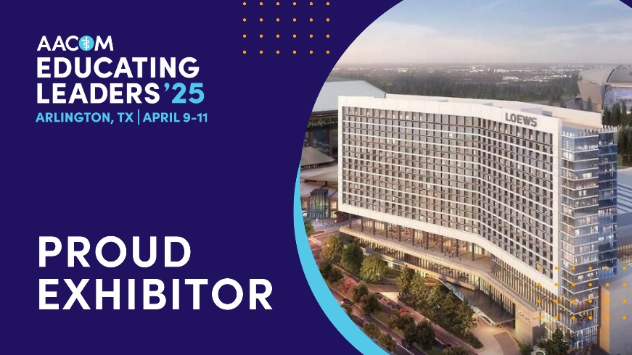 

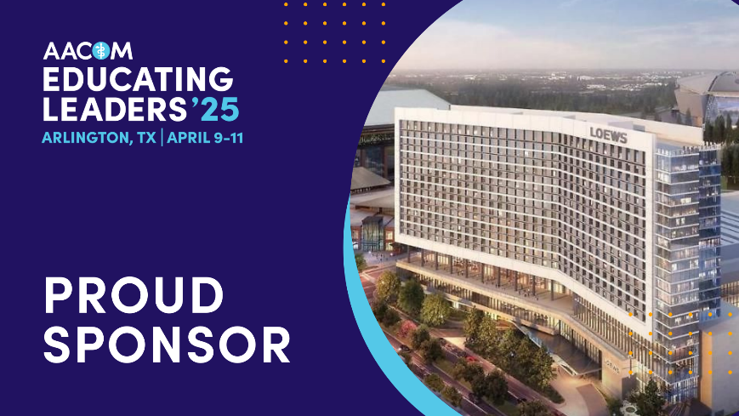 

**EMAIL BANNERS**

[**Download Banners**](https://drive.google.com/drive/folders/10Z30diuUxkL63Gp82s1eQyyJRan_aP5i?usp=drive_link)





