EDUCATING LEADERS 2024 DIGITAL TOOLKIT
The American Association of Colleges of Osteopathic Medicine (AACOM) is excited to welcome you to Educating Leaders 2024 (EL24), the AACOM Annual Conference, April 17-19. This year’s conference will be held at Loews Kansas City, in Kansas City, Missouri. Forge connections, ignite inspiration and catalyze change during this can’t miss event!
This digital toolkit provides a wide range of downloads and communications materials for AACOM’s EDUCATING LEADERS 2024 conference.
If you have any questions about the toolkit, please contact Inma Galvez-Shorts, Manager of Social Media and Analytics, at igalvez-shorts@aacom.org.
FOLLOW AACOM ON SOCIAL MEDIA
Facebook | X (formerly known as Twitter) | Instagram | LinkedIn
USE THE #HASHTAGS
#EducatingLeaders24 | #EducateLeaders | #DOleaders

DOWNLOADS AND SHAREABLES
ATTENDEE TOOLKIT
Facebook/LinkedIn
- I’m excited to be with my colleagues at AACOM’s annual conference #EducatingLeaders24! Join me on April 17-19 for the largest osteopathic medical education event in the nation, taking place in Kansas City, MO! Learn more and register at aacom.org/educatingleaders.
- Greater medical possibilities begin in Kansas City. Register for #EducatingLeaders24 today and be part of three days of thought-provoking plenary presentations, interactive sessions, special events and collaborative programming focused on timely issues facing our nation’s healthcare and medical education systems. I’ll be there! aacom.org/educatingleaders
X (formerly known as Twitter)
- Join me at @AACOMmunities’ #EducatingLeaders24 to share ideas, discuss opportunities, and gain insights into the most pressing issues regarding osteopathic medical education. Register at aacom.org/educatingleaders.
- Excited to hear from @SPEAKER, @SPEAKER, and @SPEAKER at @AACOMmunities’ #EducatingLeaders24! Who else is joining me? aacom.org/educatingleaders
- I’m excited to be a part of #EducatingLeaders24! The path to better healthcare starts with better osteopathic medical education. Learn more and register at aacom.org/educatingleaders.
Social media attendee graphics
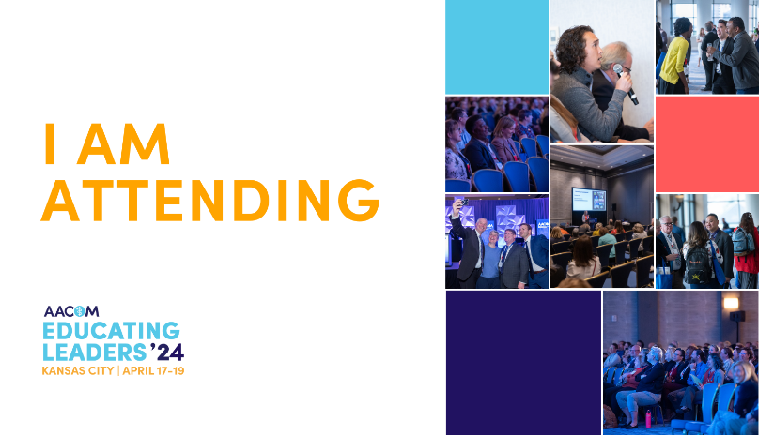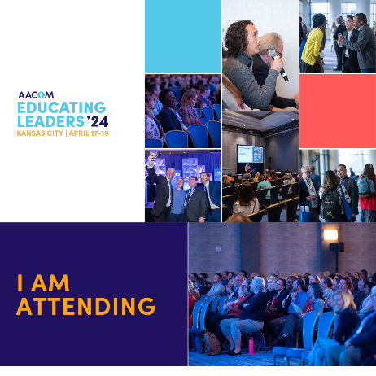
PRESENTER TOOLKIT
Facebook/LinkedIn
- I’m excited to present my work at #EducatingLeaders24! Join me and get insights into the most pressing issues regarding osteopathic medical education: workforce diversity, clinical education, osteopathic representation and more! Register here: aacom.org/educatingleaders
- I'm so excited to be a part of AACOM’s annual conference, #EducatingLeaders24! Join me on April 17-19 for the largest osteopathic medical education event in the nation, taking place in Kansas City, MO! Learn more and register at aacom.org/educatingleaders
X (formerly known as Twitter)
- I'm presenting at @AACOMmunities’ annual conference #EducatingLeaders24! Join me and other #DOleaders on April 17-19 for a celebration of #osteopathic medical education. Register here: aacom.org/educatingleaders
- I am honored to present my work at #EducatingLeaders24. Register and join me in Kansas City or online at @AACOMmunities’ annual conference on April 17-19! aacom.org/educatingleaders
- I'm presenting at #EducatingLeaders24! The path to better healthcare starts with better osteopathic medical education. Hope to see you there! @AACOMmunities aacom.org/educatingleaders
Social media presenter graphics
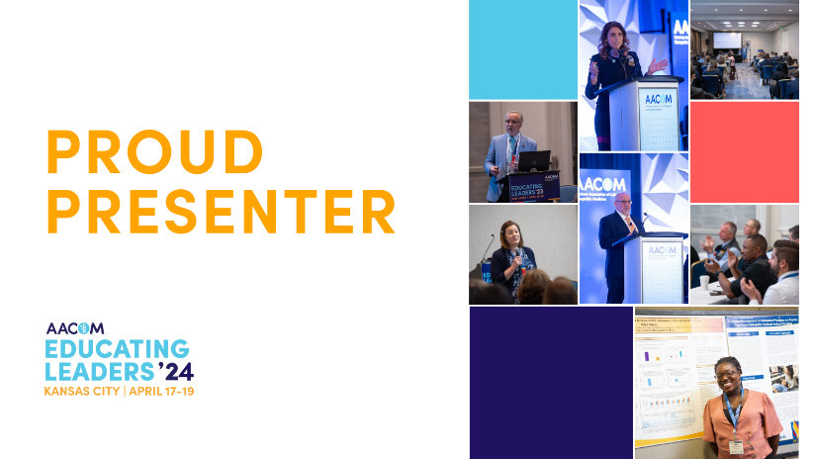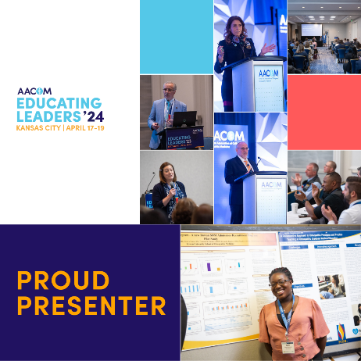

SPONSOR/EXHIBITOR TOOLKIT
Facebook/LinkedIn
- We're thrilled to be part of #EducatingLeaders24, where you can delve into three days of thought-provoking plenary presentations, interactive sessions, special events, and collaborative programming focused on critical issues in healthcare and medical education. Join us from April 17-19 in Kansas City, MO. Register and learn more at aacom.org/educatingleaders.
- We take pride in being an exhibitor at #EducatingLeaders24! Register now and connect with leaders in osteopathic medical education, including students, educators, admissions professionals, resident & fellow physicians, program directors, and more. They'll all be at Educating Leaders! Join us from April 17-19 in Kansas City, MO. Learn more at aacom.org/educatingleaders.
X (formerly known as Twitter)
- We're a proud sponsor of #EducatingLeaders24, where you can connect with leaders in #osteopathic #meded. From students and educators to admissions professionals, resident & fellow physicians, program directors, and more. Join us in Kansas City, MO from April 17-19. Learn more at aacom.org/educatingleaders.
- We're honored to be an exhibitor at @AACOMmunities’ #EducatingLeaders24, where you can join us for three days of thought-provoking presentations, interactive sessions, events, and collaborative programming. Register today at aacom.org/educatingleaders!
Social Media Exhibitor/Presenter Graphics
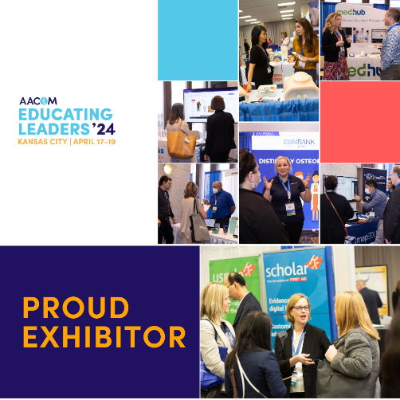
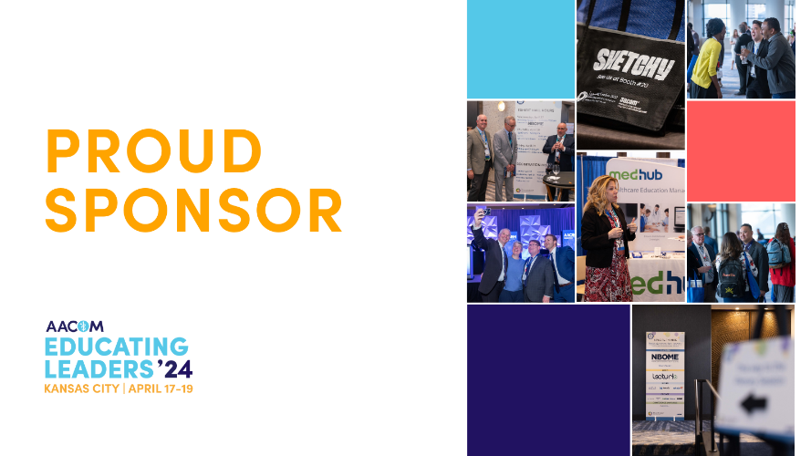
EMAIL BANNERS
Download Banners
